Instruction

* Interface

1. Connect to login page:

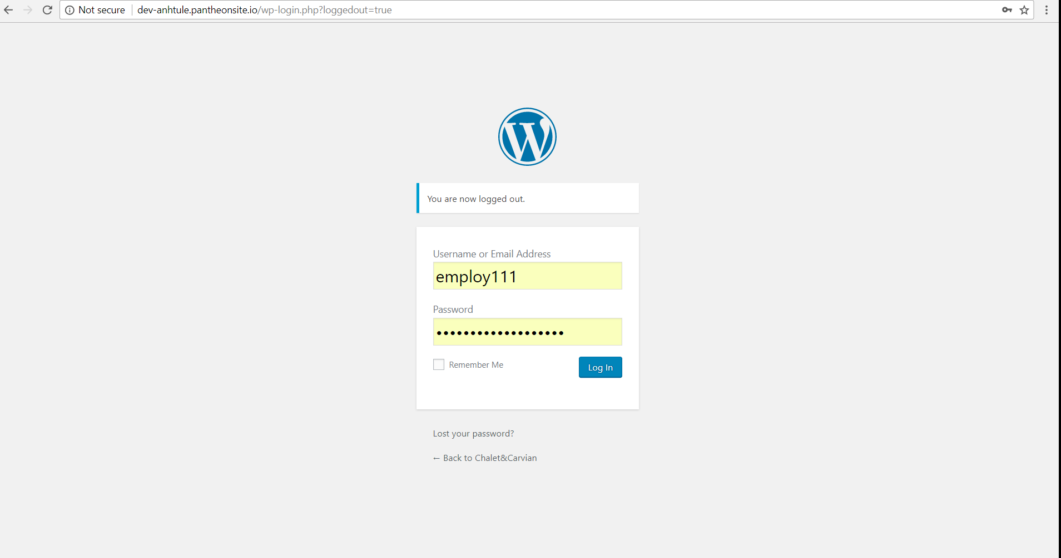

1. After you logged in, you will see this dashboard

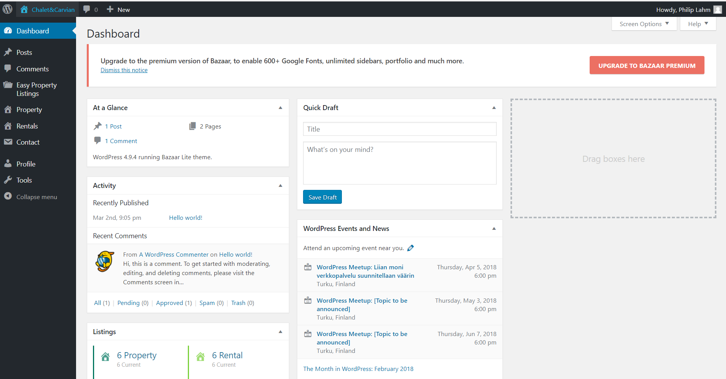

On the left side, we will have navigation menu, you can choose a specific part to modify the page:

* Posts: is what makes up the blog aspect of your site. These are generally news or informational updates about a certain topic or talking point. **Posts** are listed in reverse chronological order and can be tagged, categorized and even archived on your site.
* Easy Property Listings: Here you can read about the instructions how to use Easy Property Listings plugin, and install some add-ons that need to be used later on tu support for the administrator to control and modify the page
* Property Listing:

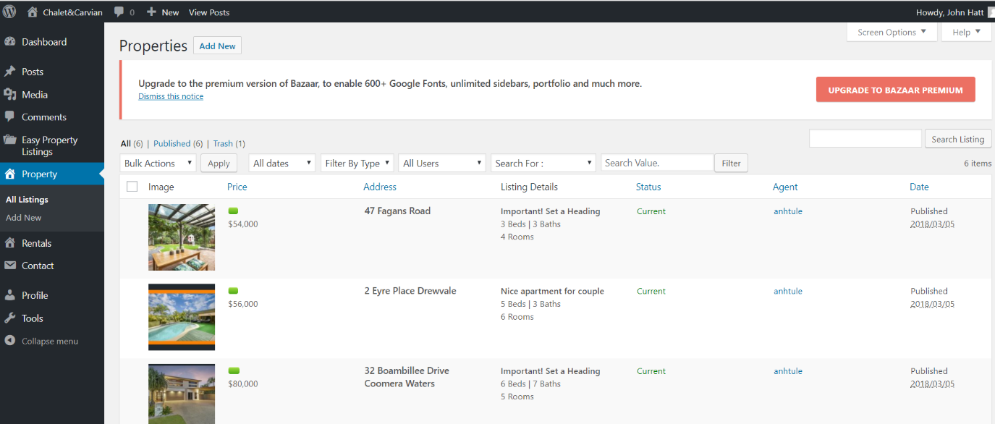

In this panel, you can add a new property to For Sale Page, or we can have an overlook at all the properties that are available in your page

* Rentals

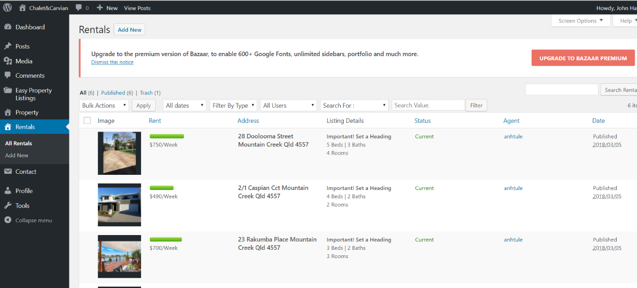

In this panel, you can add a new property to For Rent Page, or we can have an overlook at all the properties that are available in your page

* Contact

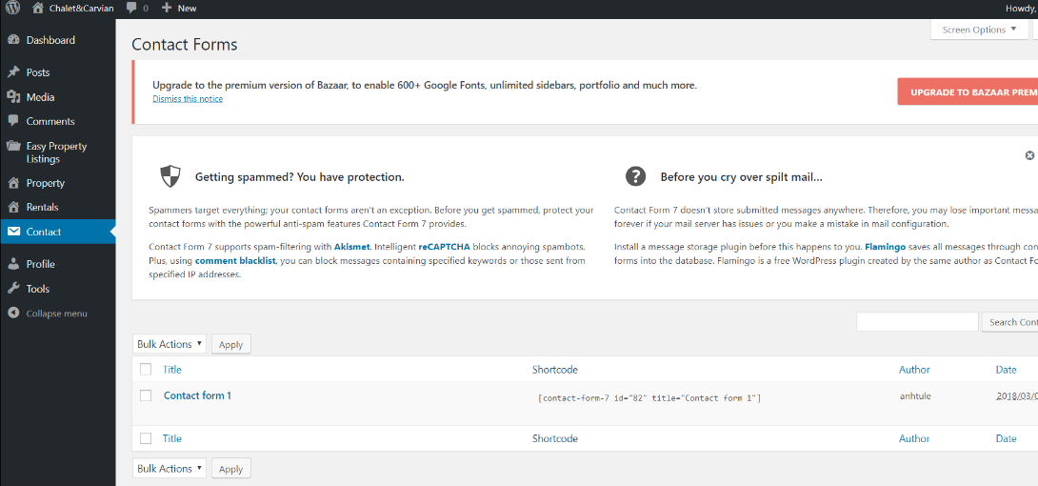

Here we can manage all the contact form in the page, and create a new one to get contact information.

* Profile: At this point, you can update your information

**HOW TO USE**

* 1. How to create a new property

Choose Property tab 🡪 add new

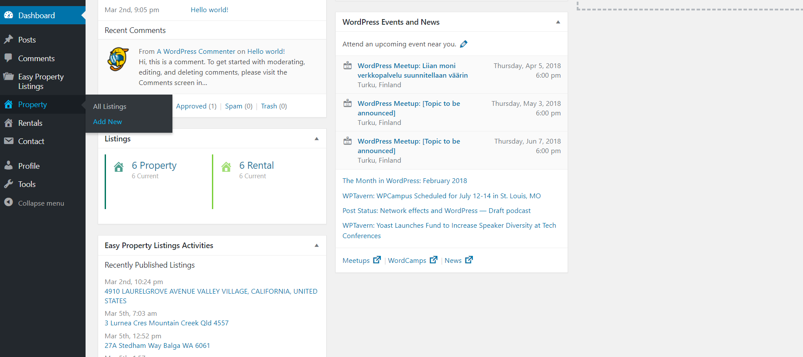

As you can see the image below, you can add the title of the post at the place (1), after that you can type the more text for detailed in the box which is (2)

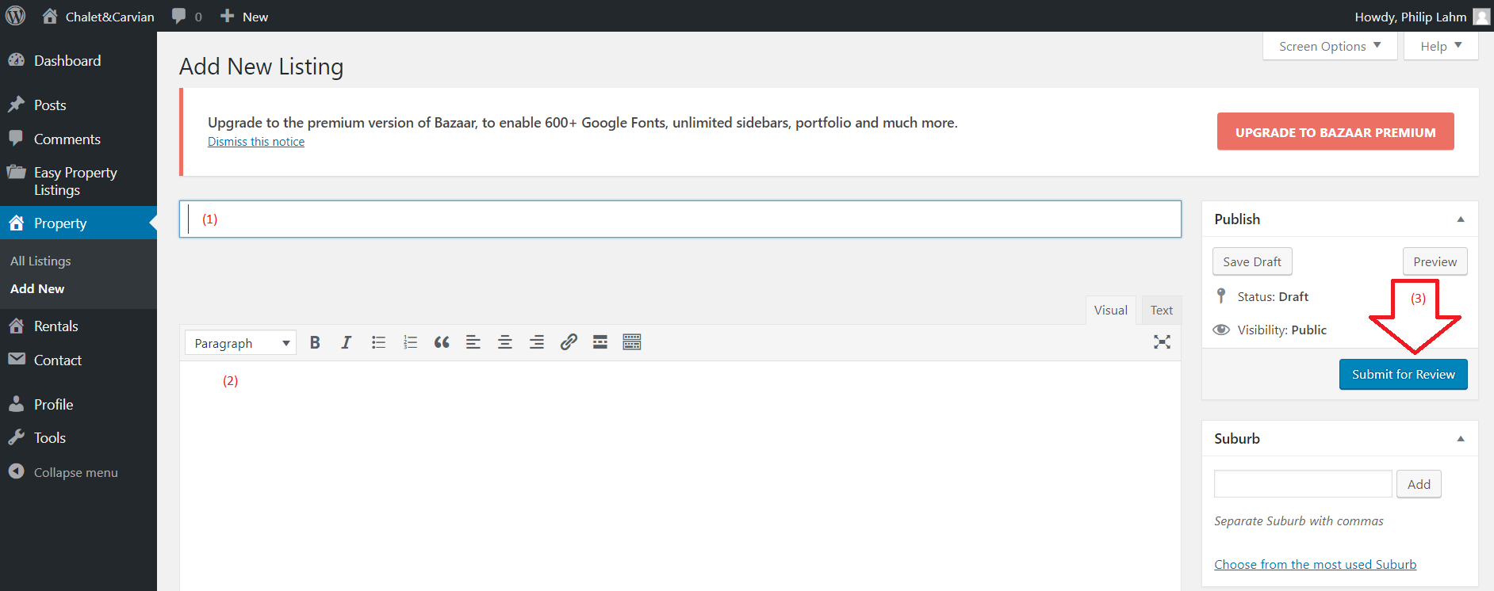

To describe the property in detail, we can scroll down to stick or fill in the box which the property have

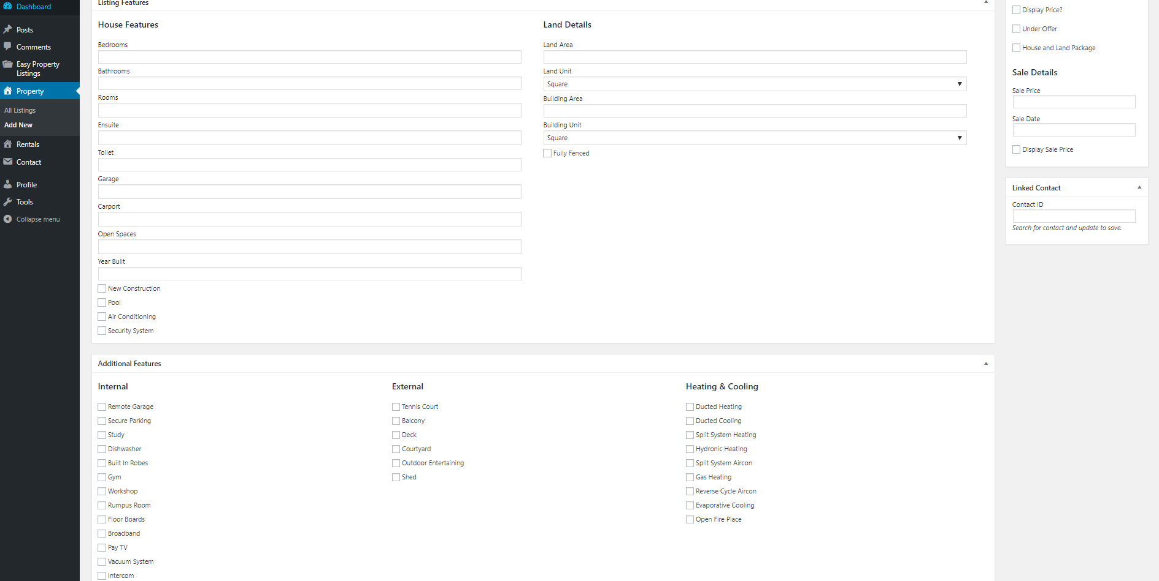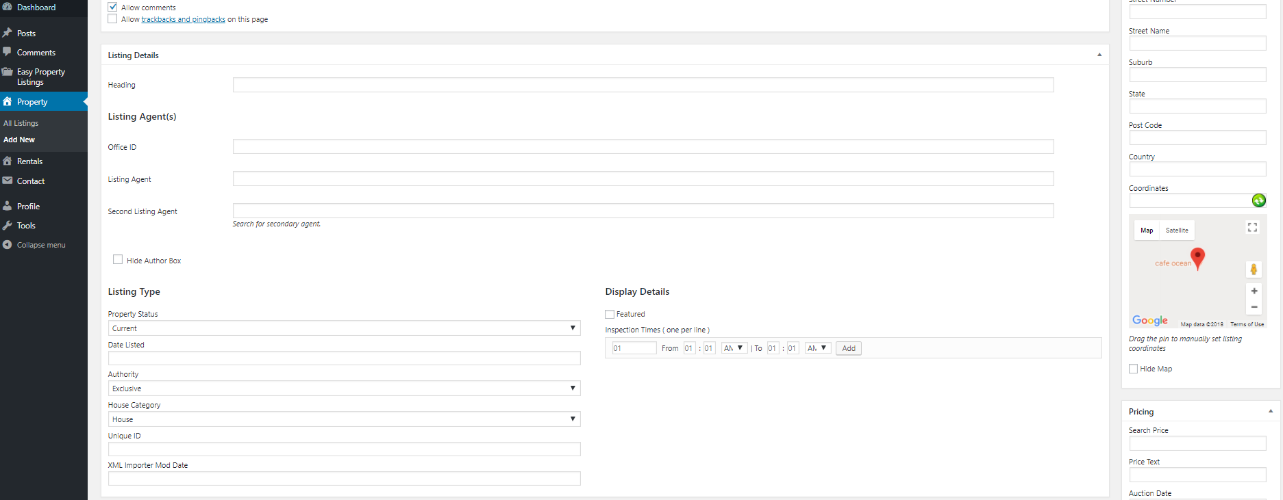

Finally, after all changes are made, you can Submit to review, which is (3), to publish the property to web page.

* 1. How to edit or delele a property:
* To Edit

Choose Property tab 🡪 All Listings

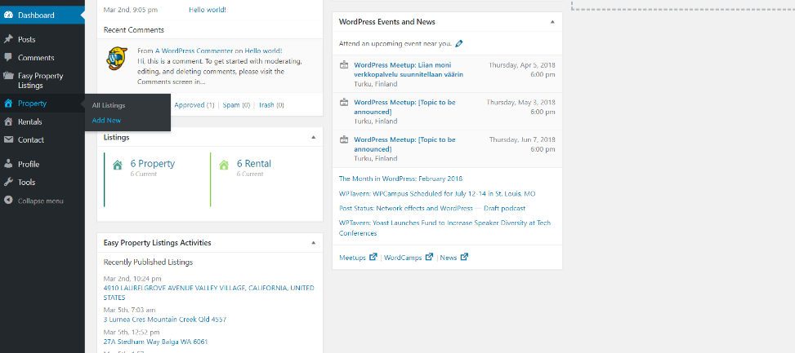

As the image below, you can choose the property that you want to edit, then just click to the property, it will lead to the edit page, which is the same when you create a new property.

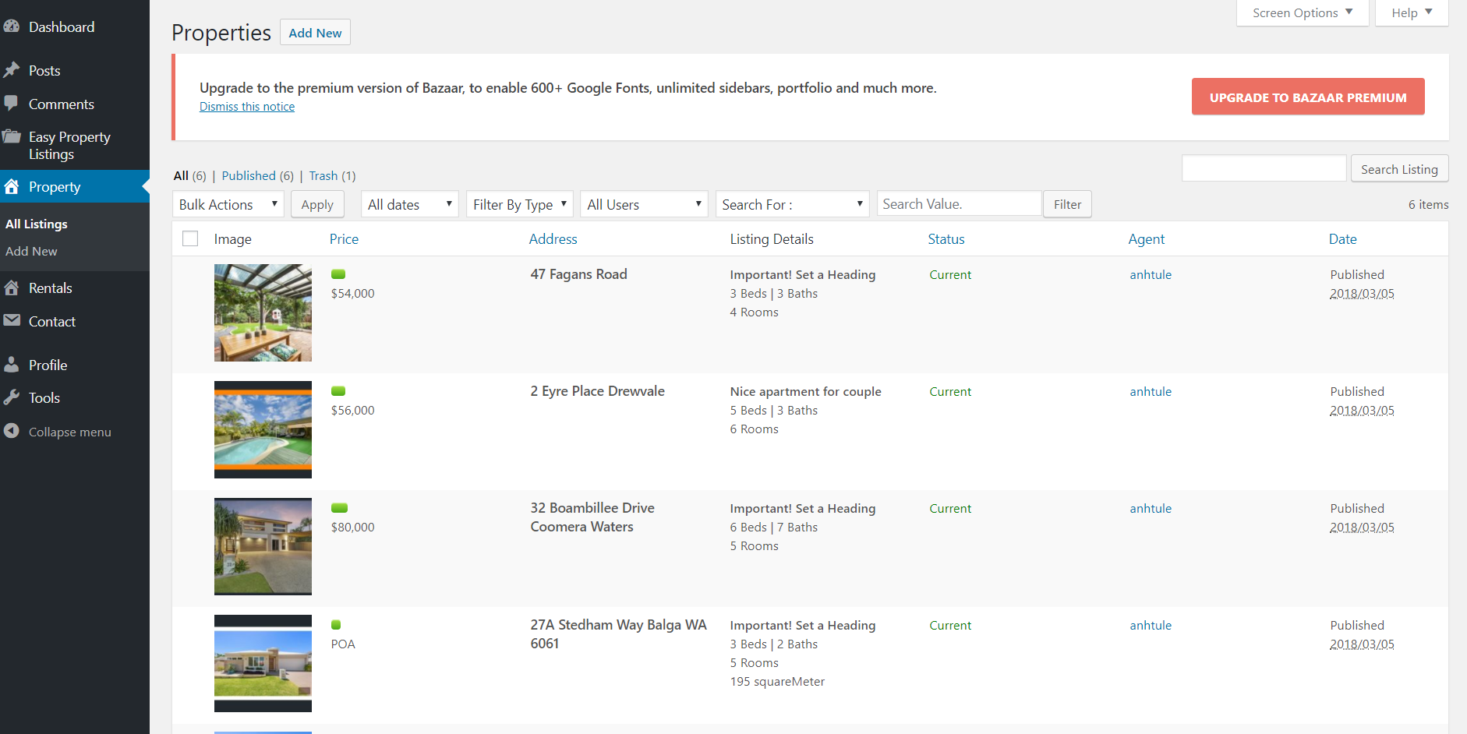

* To delete

In the All listings interface, you can choose the property that you want to delete.

Next, you will stick to the box on the left side of the picture, then move to Bulk Actions, choose Move to trash. Finally press Apply

